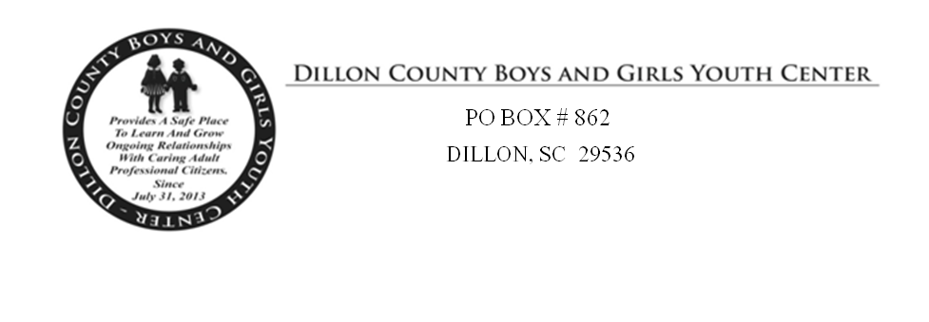

Membership Application (One Name Per Application)

Name of Participant (please print)
_________________________________________

Birth Date (Month & Year) ______________________
Race: _______________ Sex: __________

Address: ___________________________________
___________________________________
___________________________________

Home Phone (________) _____________________
Work Phone (________) ______________________
Cell Phone (________)___________________

Email:________________________________

___________________________ ______________________
Signature Date
__________________________ _______________________
Witness Signature Date
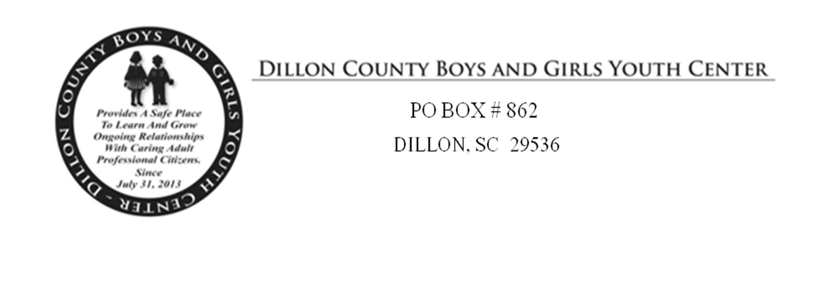
Name (please print) _________________________________________

Activity Responsibility Agreement
I, the undersigned, understand that there are risks and dangers inherent in participating in The Dillon County Boys and Girls Youth Center, hereinafter “Activity”, which may include transportation, for a time period of up to one year. I also understand that in order to be allowed to participate in this Activity and associated Activities, I must agree not to hold The Dillon County Boys and Girls Youth Center liable for any injury or damage which I may suffer while participating in any Activity or going to/from any Activity.
Knowing this, and in consideration of being permitted to voluntarily participate in any Activity, and recognizing the charitable nature of The Dillon County Boys and Girls Youth Center, I hereby voluntarily release The Dillon County Youth Center from any and all liability resulting from or arising in any manner whatsoever out of any participation in any Activity.
• I understand and agree that I am releasing not only The Dillon County Boys and Girls Youth Center, but also its officers, agents, and employees. I understand and agree that this waiver/release will have the effect of releasing, discharging, saving and forever relinquishing any and all actions or causes of action that I may have or have had, whether past, present, or future; whether known or unknown, and whether anticipated or unanticipated by me, whether through acts or omissions by The Dillon County Boys and Girls Youth Center personnel or other unrelated third parties or other participants.
• I understand and agree that this waiver/release will be binding on me, my spouse, my heirs, my personal representatives, my assignees, my children, and any guardian and item for said children.
• I understand and agree that by signing this waiver/release, I am assuming full responsibility for any and all risk of death or personal injury or property damage suffered by me while participating in any Activity, including but not limited to health care expenses.
• I understand and agree that by signing this waiver/release, I am agreeing to release, indemnify and hold The Dillon County Boys and Girls Youth Center, its officers, agents or employees harmless from any and all liability or costs, including attorney’s fees, associated with or arising from my participation in any Activity.
• I understand and agree that I am signing this waiver/release on behalf of my minor child that I will be giving up the same rights for said minor as I would be giving up if I had signed this document of my own behalf.

• I UNDERSTAND THAT THIS IS A LEGAL DOCUMENT.
I acknowledge that I have read this waiver/release agreement and that I understand the words and language in it. I understand there are potential dangers incidental to participating in any activity and going to/from any activity. I execute it voluntarily and with full knowledge of its meaning and significance.

___________________________ _________
Signature Date

Name of Participant (please print) _________________________________________

First Aid and Emergency Medical Treatment
I recognize that there may be occasions I, if I am a participant, may be in need of first aid or emergency medical treatment as a result of an accident, illness, or other health condition or injury I do hereby give permission for agents of The Youth Center to seek and secure any needed medical attention or treatment myself, if I am a participant, including hospitalization if in the agent’s opinion such need arises. In doing so, I agree to pay all fees and costs arising from this action to obtain medical treatment.

I give permission for attending physician(s) and other medical personnel to administer any needed medical treatment, including surgery and, again; I agree to pay for the medical treatment.

Medical History
Special medical needs or concerns (allergies, conditions, dietary needs, medications, etc.):
Health Insurance Information
Insurance Company: _______________________________________________
Policy Number: ___________________________________________________
Phone Number: ___________________________________________________
Medical Doctor: ___________________________________________________

Emergency Contacts
Names of persons and telephone numbers to call in case of emergency:
1. Name: ___________________________ Phone Number:________________
2. Name: ___________________________ Phone Number:________________
3. Name: ___________________________ Phone Number:________________

Swimming Ability
-  Non-swimmer
-  Beginner (capable of swimming for several minutes in deep water)
-  Moderate (capable of swimming several lengths of pool)
-  Advanced (capable of swimming long distances)
Other Information
Other information leaders should know about the child or adult participant: ____________________________
________________________________________________________________________________________________________________________________________________________________________________

__________________________ ___________
Signature Date

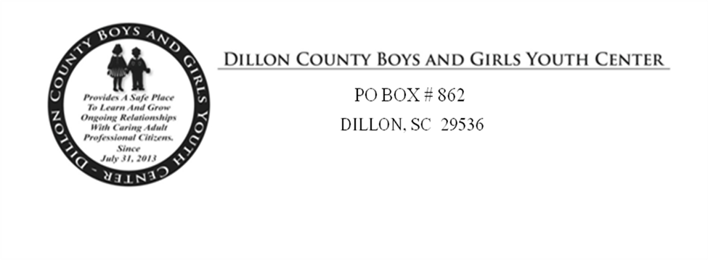

Name of Child or Youth Participant (please print) _________________________________________
Parent(s) and/or legal guardian(s) of child participant ______________________________________

Special Events and Field Trips
I understand that the child named above will be participating in Boys & Girls Youth Center Activities from January 1st, 20____ until December 31, 20____. I understand that during this period my child/youth may take part in activities such as: games, sports, fieldtrips, and other activities consistent with the purposes of the unit/program.

I agree that my child/youth can be transported in a Dillon County Boys & Girls Youth Center vehicle to and from school and any Youth Center Activity.

CODE OF CONDUCT

1. This is my home away from home, I will treat it with respect, I will keep it clean.
2. I will respect my fellow club members.
3. I will strive to keep my mind, body, and language clean.
(a) I will develop my mind so as to control my thoughts and actions.
(b) I will develop my body to keep it clean and healthy.
(c) I will develop my language, as it tells others what I am.

4. In my club I will be fully clothed.
(a) I will not wear a hat in my club.
(b) I will not wear swimsuits or short shorts in the program area.
(c) My coat or sweater and other personal belongings will be put in the proper place.

5. Our game room equipment will be used with respect.
(a)I will not sit on any tables.
(d) I will not allow any equipment to be mistreated.

6. My conduct shows what kind of person I am.
(a) I will not run in my club.
(b) I will not smoke in my club.
(c) I will not fight in my club.
(d) I will not gamble in my club.
(e) I will not take part in, or allow horseplay in my club.

7. When traveling, as a club representative, I will be well dressed and well behaved.
8. If I do not respect my club I know I will be suspended.
9. Above all I will respect and obey my club staff.
10. When visiting other clubs/community centers, I will always conform to the “CODE OF CONDUCT” established by the local club/community center.

CLUB MEMBER SIGNATURE _____________________________________________

PARENT SIGNATURE ___________________________________________________

Date:_____________________

